IF YOU ARE FACING ERROR MESSAGE WHILE RUNNING THE FILE:

“download me first.bat”

ERROR MESSAGE DISPLAY:
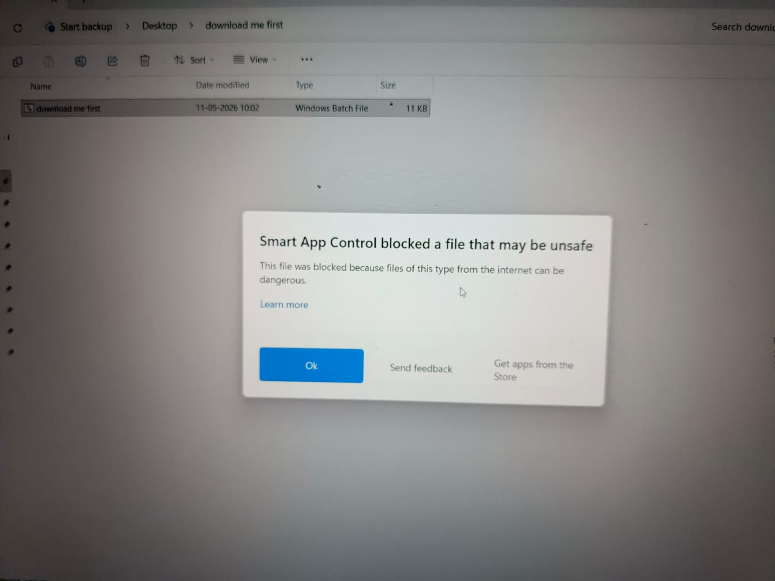

FOLLOW THIS STEPS TO RUN THE APPLICATION:
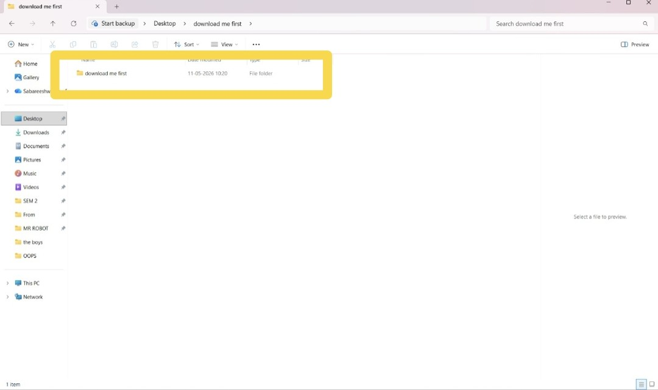
1. After extracting/unzipping the “download_me_first” file, open the extracted folder named “download_me_first.”

2. Inside the folder, locate the file named “download_me_first.bat.”
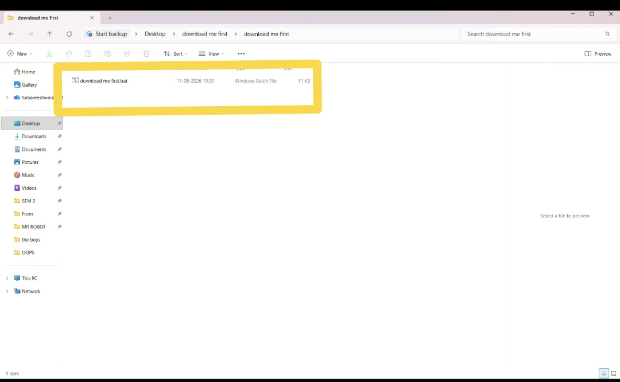

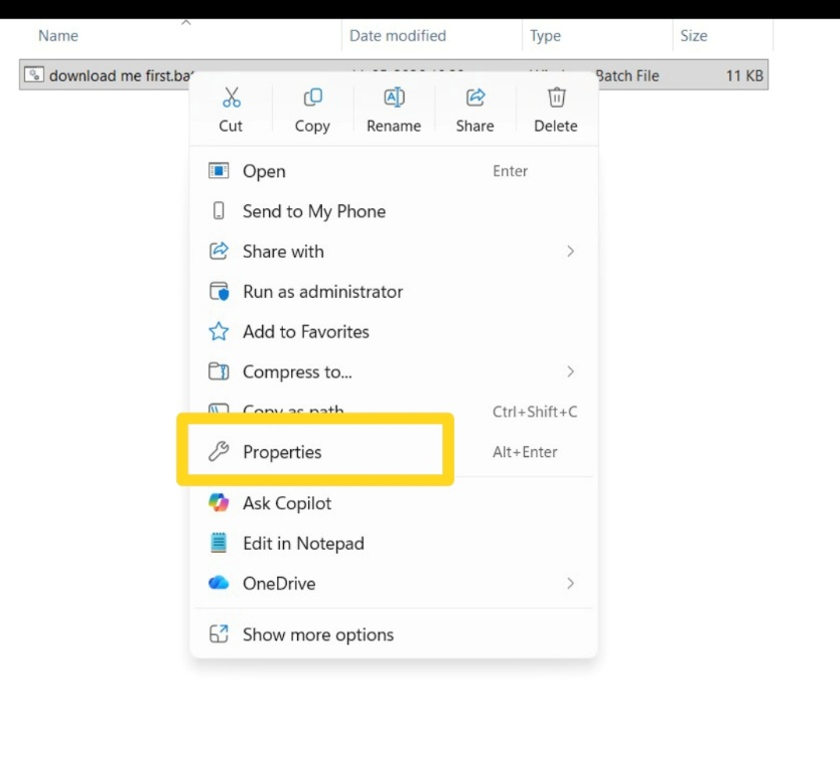
3. Move your mouse cursor over the download_me_first.bat file and right-click on it to open the options menu.

4. From the menu that appears, click on Properties. This will open the file settings window.
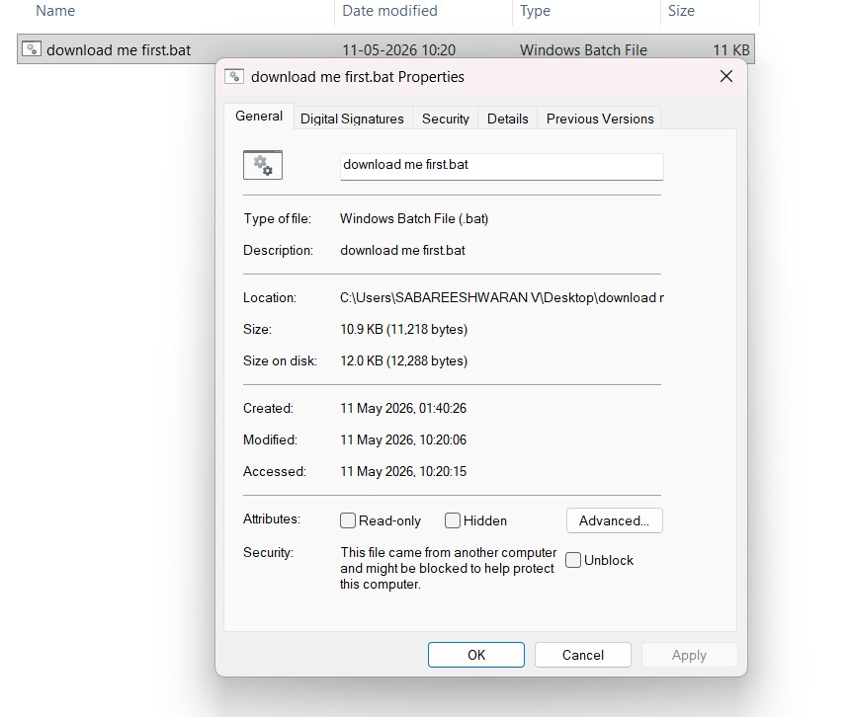

5. In the Properties window, make sure you are on the General tab.
- This tab usually opens automatically by default.
6. Scroll to the very bottom of the General tab and look for a section called Security.
- You may see a message similar to:
“This file came from another computer and might be blocked to help protect this computer.”
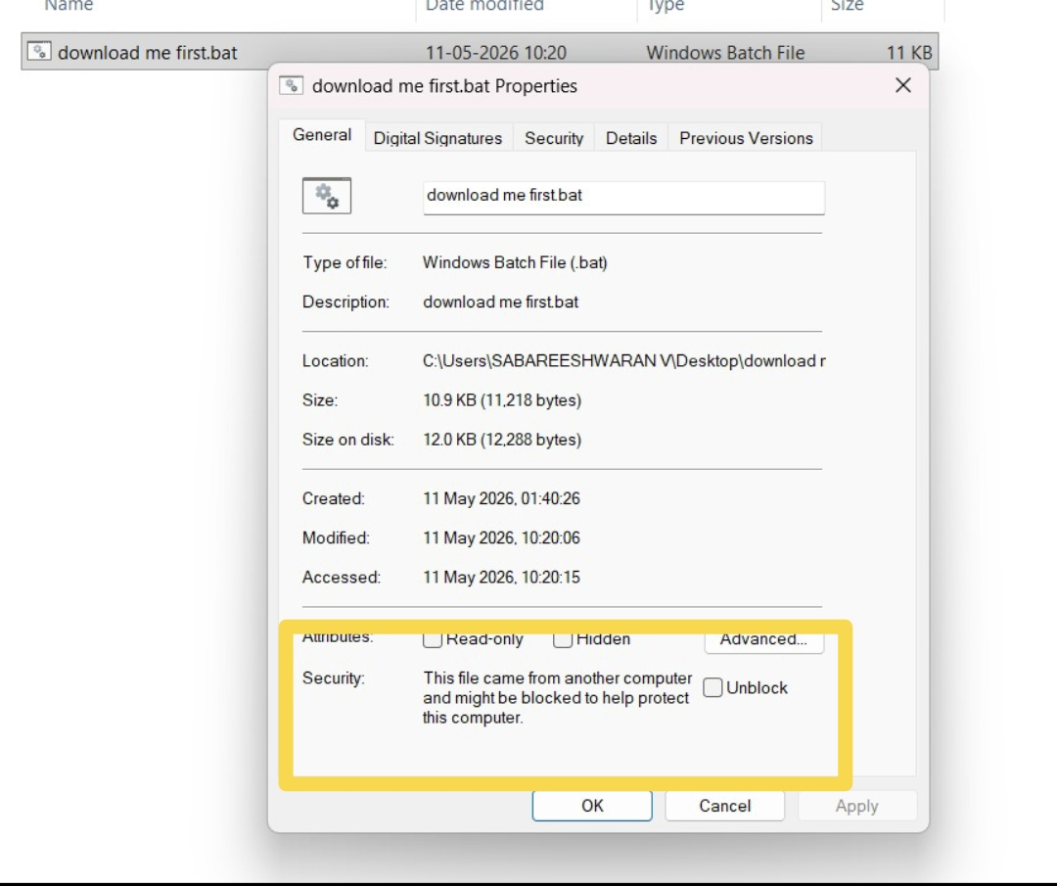

7. Below this message, you will find a checkbox labeled Unblock.
- Click the checkbox to place a tick mark in it.
- This will allow Windows to run the file without security restrictions.
8. After checking the Unblock option, click the Apply button located at the bottom-right corner of the window.
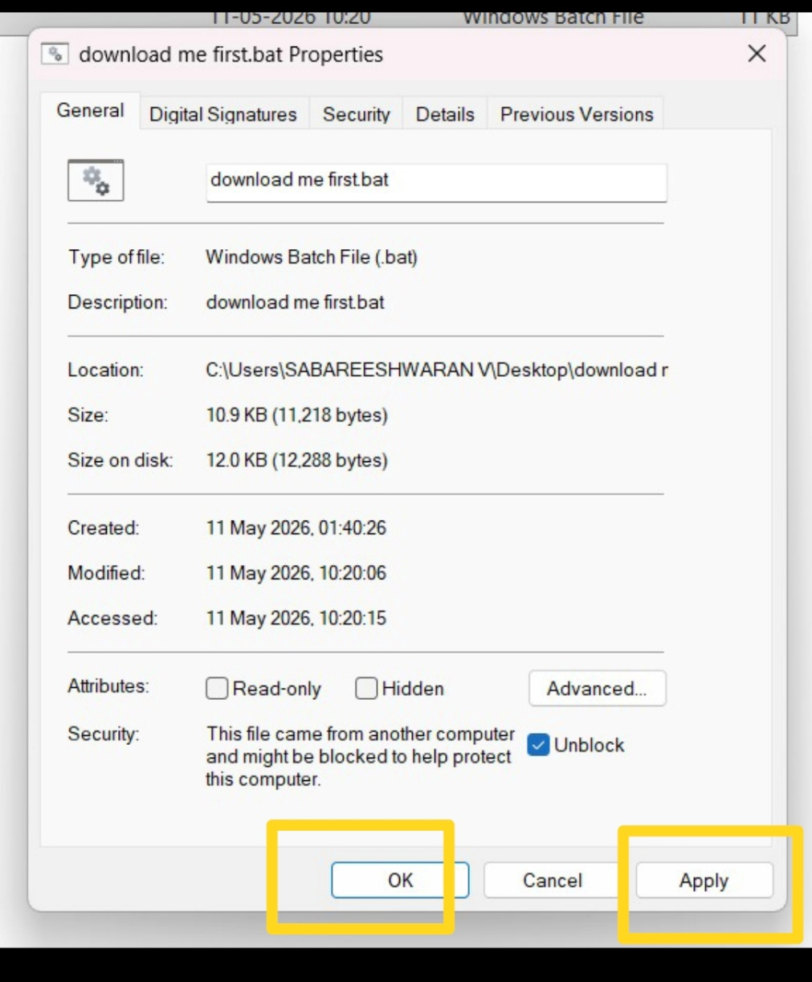
9. Then click OK to save the changes and close the Properties window.

10. You can now run the download_me_first.bat file normally by double-clicking it.

